|  |
| --- |
| Image result for charlie brown january clip art  East Newton Elementary  January 2019  Where it’s a great place to have  PAW PRIDE! |

|  |  |  |  |  |  |  |
| --- | --- | --- | --- | --- | --- | --- |
| Sunday | Monday | Tuesday | Wednesday | Thursday | Friday | Saturday |
|  |  | **1** | **2** | **3** | **4** | **5** |
| Image result for snowflake clipart |  | Image result for new year clip art |  |  |  | Image result for snowflake clipart |
| **6** | **7** | **8** | **9** | **10** | **11** | **12** |
| Image result for snowflake clipart | **Teacher Work Day**  **No School for Students** | **Students Return**  **Welcome to the New Year!** |  | **Report Cards**  Image result for report card clip art |  | Image result for snowflake clipart |
| **13** | **14** | **15** | **16** | **17** | **18** | **19** |
| Image result for snowflake clipart |  | Image result for student of the month clipart  **Program at 8:30 a.m.** |  |  | **Kindergarten Fieldtrip to Andy Irwin at Porter** | Image result for snowflake clipart |
| **20** | **21** | **22** | **23** | **24** | **25** | **26** |
| Image result for snowflake clipart | **MLK Day**  **No School** |  |  |  |  | Image result for snowflake clipart |
| **27** | **28** | **29** | **30** | **31** |  |  |
| Image result for snowflake clipart |  |  |  |  |  | Image result for snowflake clipart |
|  |  |  |  |  |  |  |
|  |  |  |  |  |  |  |
|  |  |  |  |  |  |  |
|  |  |  |  |  |  |  |
|  |  |  |  |  |  |  |
|  |  |  |  |  |  |  |
|  |  |  |  |  |  |  |
|  |  |  |  |  |  |  |
|  |  | Image result for student of the month clipart |  |  |  |  |

[](https://www.google.com/url?sa=i&rct=j&q=&esrc=s&source=images&cd=&cad=rja&uact=8&ved=2ahUKEwjJ89Ght_LeAhVB6VMKHa4RDLMQjRx6BAgBEAU&url=https://www.istockphoto.com/illustrations/santa-hat&psig=AOvVaw2HEX844q894GwLjDzMB9qT&ust=1543334470377048)

[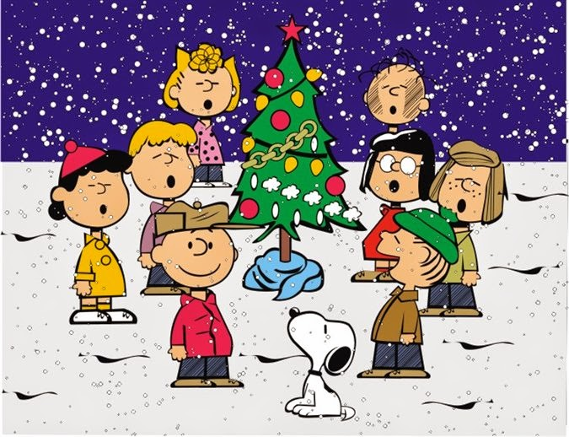](http://www.google.com/url?sa=i&rct=j&q=&esrc=s&source=images&cd=&cad=rja&uact=8&ved=2ahUKEwil9uSRvfLeAhVO1IMKHRx9A-oQjRx6BAgBEAU&url=http://holiday.filminspector.com/2014/11/charlie-brown-clip-art-and-coloring.html&psig=AOvVaw1Kqekop7O0QwoJKid9BRN7&ust=1543335884718044)