East Newton Elementary
March 2019
Where it’s a great place to have
PAW PRIDE!

Sunday | Monday | Tuesday | Wednesday | Thursday | Friday | Saturday
 |  |  |  |  | 1 | 2
 |  |  |  |  | 5th Grade - IOWA
3 | 4 | 5 | 6 | 7 | 8 | 9
 | 4th Grade - IOWA  5th Grade - IOWA  Wear stripes or red & white for Dr. Seuss | 4th Grade - IOWA  5th Grade – IOWA  Crazy socks day | 4th Grade - IOWA  5th Grade – IOWA  College shirt or jersey | 4th Grade - IOWA  5th Grade – IOWA  Wear a hat | 3rd Grade - IOWA  2nd Grade Fieldtrip  Wear East Newton shirt
10 | 11 | 12 | 13 | 14 | 15 | 16
 |  | Student of the Month  8:30 | 3rd - IOWA | 3rd - IOWA  Title I Meeting | 3rd - IOWA  Early Release  11:00
17 | 18 | 19 | 20 | 21 | 22 | 23
 | 5th Grade Fieldtrip |  |  | Help a Child Smile  Report Cards | 1st session 5:00- 6:30  2nd session 7:00- 8:30 | Media Festival
24 | 25 | 26 | 27 | 28 | 29 | 30
 |  |  | Spring Pictures | Jump rope for Heart  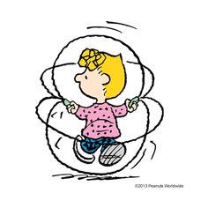 | Career Day
31

