|  |
| --- |
| [Image result for peanuts character valentine clipart](https://www.google.com/imgres?imgurl=https://img.clipartimage.com/love-snoopy-valentines-day-snoopy-and-woodstock-snoopy-love-charlie-brown-valentine-charlie-brown-valentines-day-clipart-225_244.jpg&imgrefurl=https://clipartimage.com/clipart/24112-charlie-brown-valentines-day-clipart.html&docid=IbzxUAt3RcyfVM&tbnid=hJtnnoMS2Bq5DM:&vet=12ahUKEwit1sST0pPgAhXNslkKHaujCEQ4yAEQMygHMAd6BAgBEAg..i&w=225&h=244&bih=754&biw=1440&q=peanuts%20character%20valentine%20clipart&ved=2ahUKEwit1sST0pPgAhXNslkKHaujCEQ4yAEQMygHMAd6BAgBEAg&iact=mrc&uact=8)  East Newton Elementary  February 2019  Where it’s a great place to have  PAW PRIDE! |

|  |  |  |  |  |  |  |
| --- | --- | --- | --- | --- | --- | --- |
| Sunday | Monday | Tuesday | Wednesday | Thursday | Friday | Saturday |
|  |  |  |  |  | **1** | **2** |
|  |  |  |  |  | **Early Release Day**  **11:00**  [Image result for happy kids clipart](https://www.google.com/url?sa=i&rct=j&q=&esrc=s&source=images&cd=&cad=rja&uact=8&ved=2ahUKEwjimMHK1JXgAhVvhuAKHUMbBk4QjRx6BAgBEAU&url=https://www.pinterest.com/pin/271693789999529311/&psig=AOvVaw2VNSEPjRNQrwubrT5Fz7K9&ust=1548943023408660) | **Daddy Daughter Dance**  **6 pm – 8 pm**  [Image result for father daughter dance clipart](https://www.google.com/imgres?imgurl=https://i.pinimg.com/236x/4c/a4/de/4ca4de795368decac2740cfe49f01fa6--daddy-daughter-tattoos-daddy-daughter-dance.jpg&imgrefurl=https://www.pinterest.com/pin/384987468126498189/&docid=dvtVDRF_kRiikM&tbnid=KZIuO07VbwkndM:&vet=10ahUKEwjSifKpx5XgAhUnh-AKHWDuBb8QMwhtKBUwFQ..i&w=173&h=300&bih=408&biw=1350&q=father%20daughter%20dance%20clipart&ved=0ahUKEwjSifKpx5XgAhUnh-AKHWDuBb8QMwhtKBUwFQ&iact=mrc&uact=8) |
| **3** | **4** | **5** | **6** | **7** | **8** | **9** |
|  | **Pre – K Registration**  **Monday, Wednesday, Thursday and Friday – 8:30 – 1:00**  **Tuesday – 8:30 – 6:00**  [Image result for pre k clipart](http://www.google.com/url?sa=i&rct=j&q=&esrc=s&source=images&cd=&cad=rja&uact=8&ved=2ahUKEwjHtc6t0ZXgAhWRTt8KHVF6BucQjRx6BAgBEAU&url=http://clipart-library.com/pre-k-cliparts.html&psig=AOvVaw0PpJRXScPOrTgAskWG2axg&ust=1548942124914670) |  |  |  | [Image result for pre k clipart](http://www.google.com/url?sa=i&rct=j&q=&esrc=s&source=images&cd=&cad=rja&uact=8&ved=2ahUKEwjHtc6t0ZXgAhWRTt8KHVF6BucQjRx6BAgBEAU&url=http://clipart-library.com/pre-k-cliparts.html&psig=AOvVaw0PpJRXScPOrTgAskWG2axg&ust=1548942124914670) |  |
| **10** | **11** | **12** | **13** | **Valentine’s Day 14** | **15** | **16** |
|  |  | **Student**  **of the Month**  Image result for student of the month clipart | **CHAMPS Graduation 9:00 am – Gym**  [Image result for choosing healthy activities and methods promoting safety](https://www.google.com/url?sa=i&rct=j&q=&esrc=s&source=images&cd=&cad=rja&uact=8&ved=2ahUKEwiS0oDyzZXgAhWmdt8KHTtCD9cQjRx6BAgBEAU&url=https://crispcountysheriff.com/c-h-a-m-p-s&psig=AOvVaw3KVvTyClthkfhWUGeEtnPE&ust=1548941221026334) | [Image result for hearts clipart](http://www.google.com/url?sa=i&rct=j&q=&esrc=s&source=images&cd=&cad=rja&uact=8&ved=2ahUKEwi8ldig0pXgAhUwiOAKHWUOANYQjRx6BAgBEAU&url=http://worldartsme.com/three-hearts-clipart.html&psig=AOvVaw2x-8heiWGjedAK-MEV8Dpe&ust=1548942399991858)  **Mid -Winter Break 14th – 19th** |  |  |
| **17** | **18** | **19** | **20** | **21** | **22** | **23** |
| **Mid -Winter Break 14th – 19th**  [Image result for hearts clipart](http://www.google.com/url?sa=i&rct=j&q=&esrc=s&source=images&cd=&cad=rja&uact=8&ved=2ahUKEwi8ldig0pXgAhUwiOAKHWUOANYQjRx6BAgBEAU&url=http://worldartsme.com/three-hearts-clipart.html&psig=AOvVaw2x-8heiWGjedAK-MEV8Dpe&ust=1548942399991858) [Image result for hearts clipart](http://www.google.com/url?sa=i&rct=j&q=&esrc=s&source=images&cd=&cad=rja&uact=8&ved=2ahUKEwi8ldig0pXgAhUwiOAKHWUOANYQjRx6BAgBEAU&url=http://worldartsme.com/three-hearts-clipart.html&psig=AOvVaw2x-8heiWGjedAK-MEV8Dpe&ust=1548942399991858) |  |  |  | **African American**  **Live Museum**  **6:00**  [Image result for black history clipart](http://www.google.com/url?sa=i&rct=j&q=&esrc=s&source=images&cd=&cad=rja&uact=8&ved=2ahUKEwjepryEz5XgAhVRPN8KHbodDm0QjRx6BAgBEAU&url=http://la-union.org/black-history-month-for-kindergarten/black-history-month-for-kindergarten-best-of-children-s-short-poems/&psig=AOvVaw1aXQVupHT-5HLov_ReDlQ6&ust=1548941479999052) |  |  |
| **24** | **25** | **26** | **27** | **28** |  |  |
|  | **Book Fair**  **25th – 28th** |  |  | **Title I**  **Family Math Night**  **6:00** |  |  |
|  |  |  |  |  |  |  |
|  |  |  |  |  |  |  |
|  |  |  |  |  |  |  |
|  |  |  |  |  |  |  |
|  |  |  |  |  |  |  |
|  |  |  |  |  |  |  |
|  |  |  |  |  |  |  |
|  |  |  |  |  |  |  |
|  |  | Image result for student of the month clipart |  |  | [Image result for father daughter dance clipart](https://www.google.com/imgres?imgurl=https://i.pinimg.com/236x/4c/a4/de/4ca4de795368decac2740cfe49f01fa6--daddy-daughter-tattoos-daddy-daughter-dance.jpg&imgrefurl=https://www.pinterest.com/pin/384987468126498189/&docid=dvtVDRF_kRiikM&tbnid=KZIuO07VbwkndM:&vet=10ahUKEwjSifKpx5XgAhUnh-AKHWDuBb8QMwhtKBUwFQ..i&w=173&h=300&bih=408&biw=1350&q=father%20daughter%20dance%20clipart&ved=0ahUKEwjSifKpx5XgAhUnh-AKHWDuBb8QMwhtKBUwFQ&iact=mrc&uact=8) |  |

[](https://www.google.com/url?sa=i&rct=j&q=&esrc=s&source=images&cd=&cad=rja&uact=8&ved=2ahUKEwjJ89Ght_LeAhVB6VMKHa4RDLMQjRx6BAgBEAU&url=https://www.istockphoto.com/illustrations/santa-hat&psig=AOvVaw2HEX844q894GwLjDzMB9qT&ust=1543334470377048)

[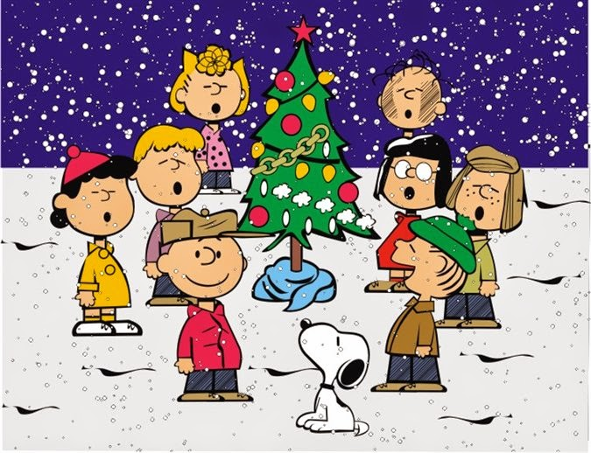](http://www.google.com/url?sa=i&rct=j&q=&esrc=s&source=images&cd=&cad=rja&uact=8&ved=2ahUKEwil9uSRvfLeAhVO1IMKHRx9A-oQjRx6BAgBEAU&url=http://holiday.filminspector.com/2014/11/charlie-brown-clip-art-and-coloring.html&psig=AOvVaw1Kqekop7O0QwoJKid9BRN7&ust=1543335884718044)